Analysis

Problem Identification

Over 400 people each year drown in UK waters, this is mostly due to mistakenly swimming in dangerous areas, and misinformation from various sources causing confusion. Therefore, this program and project acts as an easy way to determine whether it’s safe for a person to swim in a specific area of the sea, based on various fetched parameters. Therefore, helping to reduce drowning deaths by providing simplistic answer of the safety of the area to those who have little knowledge of its dangers.

Overall, the computer system needed to run this application would need an internet connection, as the parameters/conditions of the area would be fetched from live time APIs and a small processor to calculate the overall safety. It as a problem lends itself very well to a computational solution as it performs repetitive pre-programmed calculations in order to calculate an overall score/set output to give to the user in any point in a day.

Stakeholders

Overall, the clients for this application would be almost any person with an ability to use a computer, in the form of either phone, desktop, laptop, etc…. As these are the range of people who swim and use the UK waters every year. Due to this range of user abilities, the program overall has to be simplistic in order to prevent confusion, and overall portray a definite message of the hazards of the area in question. Also because of this range of people my stratified sample of users would have to represent this.

Due to a need for simplicity within this application some of the users tested would be elderly and less proficient with technology. So, if it is easy for them to use, it is easy for any other user to navigate through.

My stakeholders are Christine , Paul and Oscar. Christine understands the beaches around this area, growing up locally and being an extremely experienced open water swimmer. Previously running a swimming teaching company, as well as this she regularly completes long distance swims such as the English Channel. For her the main use of this product will be to < >. Paul is a strong swimmer yet has little knowledge of the sea and its hazards; therefore, he is looking for a way to determine whether it’s safe to swim in an area without confusing him that much. Also, Oscar has little understanding of how the conditions of the area affect the safety, plus they have an average swimming ability of someone who doesn’t engage in it regularly. Therefore, as well as providing him with a simple answer of whether it’s safe to swim the product will allow him to relax knowing the area is safe. This mix of users provide a useful insight and interpretation of the real life demographic of people using the product, providing a mix of ages and swimming abilities, plus knowledge about the sea.

In addition to this the software could also be adapted slightly and used for various other water sports at the beach such as surfing or paddle boarding; that also can be dangerous in adverse conditions and can be calculated through the data I have available.

Why it is suited to a computational solution

The problem that I am tackling is one that requires high amounts of data processing and fetching off the correct sources, this is the key advantage of a computer tackling these tasks, apposed to a human, as this is straining for many people; and they may not even bother with it even if they know how to. Also, for most people who don’t know how to complete the calculations to determine how safe it is to swim in an area, this is a perfect solution. As computers are great at performing calculations and processing high amounts of data.

Problem Abstraction:

This is the one of the main problems and the area that lends itself to a computational solution as there are hundreds if not thousands of parameters for a human going to the beach that determine whether they should swim or not, ranging from their mental state, to how much they have eaten that day to supply them with energy to deal with the cold temperatures of the UK and the physical demands of swimming for a period of time. Therefore, in order to make the task achievable we will be focusing on the main physical properties and conditions of an area, as well as considering the user as a weak swimmer, erring to the side of caution, and not to overestimate an average swimmer’s ability, allowing for a computational solution

Problem Decomposition:

The overall problem that needs to be accomplished can be broken down into various steps:

1. Fetching the weather forecast and current conditions
2. Establishing the tidal data for the particular region
3. Allowing the user to select which area they are intending to swim in
4. Searching the database of tidal information and weather conditions
5. Determining whether the conditions are acceptable to swim in for a weak swimmer
6. Display a simple to read and understand message to the user whether they can swim

Overall breaking down the problem like this is great as it allows for more efficient, and understandable code, reducing lag and increasing productivity. Therefore, also making use of the divide and conquer method of coding.

Thinking Ahead:

Within this problem a variety of data and inputs will need to be gathered. From the met office API data on wind speed (plus direction), temperature, and weather forecasts will need to be fetched. Also from the < > , tidal velocity and direction will need to be fetched for the current point in time, and a few hours into the future. These various inputs are often easily attainable, and reliable, making this problem great for a computational solution. Plus, a simplistic output is required from the program, to inform the user concisely without confusion. This is to the advantage of a computational solution as it has a pre - defined set of outputs that it can give; so, increases the simplicity to the end user.

Thinking concurrently:

This problem can be broken down into various parts which often can be run at the same time, for example the process of fetching weather data from API’s can be completed simultaneously with the tidal data look-up from the tidal data database. This allows for use of a computers multiple cores, that can compute tasks at the same time, whereas a human can only perform one task at any one time; increasing efficiency through a computational approach.

Overall problem features:

Across this problem a computational solution is far more viable than other approaches due to; it’s repetitive nature, where often a person might do a similar assessment of an area twice a day while at a beach, every time they go to one to ensure their safety. So instead of wating 10 minutes of a person’s time calculating this, a computational solution could provide a concise answer in less time. Following on from this, most people visiting the beach have no knowledge, on tides and how the weather affects the sea in a particular place, and as this computational solution provides a simplistic output, it reduces the confusion of swimmers and beach goers.

Stakeholder interviews:

Questions to ask ‘no knowledge of sea’:

The questions I am going to ask everyone are as such:

1. How often do you visit the beach, and why do you go there?
2. For how long do you spend at the beach and how long do you spend in the sea?
3. How much do you know about tides and weather conditions?
4. Do you know what influence tides and weather conditions have on the safety of a beach?
5. Would you use an application that informs you whether it’s safe to swim at a beach during a particular time period, and how often?
6. If so, why would you use this application?
7. What would make this more appealing to you?

Questions to ask ‘expert knowledge of safe swimming locations’:

The questions I am going to ask everyone are as such:

1. Define the recommended locations for average beach users and swimmers between Eastbourne and Brighton?
2. What physical properties define (a) a safe area for casual beach use and (b) a safe area for swimmers
3. What areas are the most popular locations for (a) swimming and (b) casual beach use
4. What are the causes of typical accidents in these specific areas?
5. What features would you like to see in this application that will mitigate risks for casual beach users and swimmers
6. What tidal and weather conditions will risk (a) swimmers and (b) casual beach users

Questions to ask ‘expert knowledge of ’:

The questions I am going to ask everyone are as such:

1. What are the sources of data for determining the state of the tide in terms of height and direction for a specific location at a particular time?
2. What are the sources of data for wind strength, wind direction, water temperature

For a specific location at a particular time.

1. How often do you visit the beach, and why do you go there?
2. For how long do you spend at the beach?
3. Would you use this application and how often?
4. If yes, why would you use it?
5. What would make this more appealing to you?

Experienced Swimmer

Strong Swimmer, little sea knowledge:

Weak swimmer, no sea knowledge:

Research

Existing similar solutions:

Safer Seas & Rivers Service

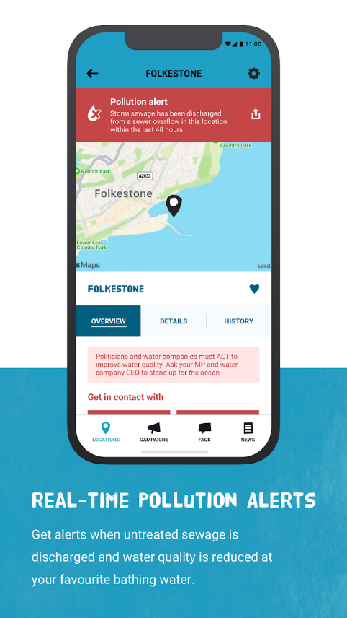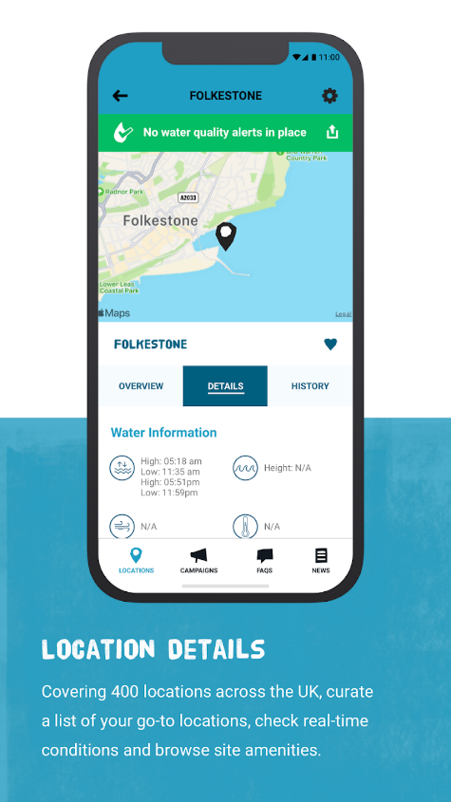**Overview:**

Safer Seas and Rivers Service has an interactive map of multiple locations within the UK. Each location has a real time reading of the water quality and pollution levels. The service alerts swimmers in the sea when a particular location has discharged untreated sewage, as well as when outputted water quality is reduced. Overall, the app allows swimmers and lifeguards to make informed decisions about when to use the sea and rivers, plus in which areas are less likely to cause illness and be polluted. In addition to this, it displays all the sea information of a particular point, including tides, wind, and sea temperatures; allowing experienced and knowledgeable swimmers and surfers to deduce the hazards in an area better.

**Parts that I can apply to my solution:**

The idea of an interactive map in which the user can select the area they are swimming in is great, as it allows more areas to be covered and detailed information provided to the users who need it. Whilst also providing a simplistic user interface so that it isn’t confusing or too dauting for new users. In addition to this the idea of having an overview of a place and the dangers it presents, whilst also having a more detailed section of information available for those who know what they are looking for, but just want a reliable source of information to make their decisions. Finally, to provide an even simpler report of the area’s threats, a colour coded banner could be used, easily providing an answer to any user looking for this information. I would in my solution use the map, of course not of the United Kingdom, but the area in my problem, then break it down beach by beach, costal town by town in order to individually provide information of each particular location. This would also be done through the use of the pop-up selection providing the necessary information, and a coloured banner simplifying everything even more for particular users.

Beach safe

**Overview:**

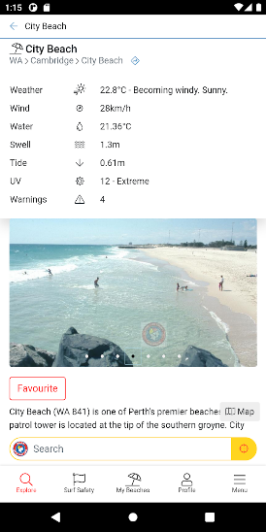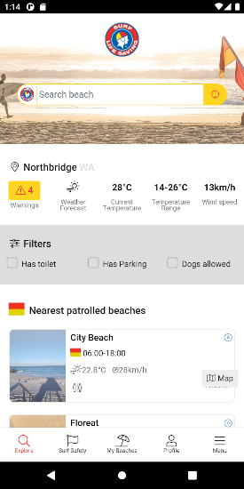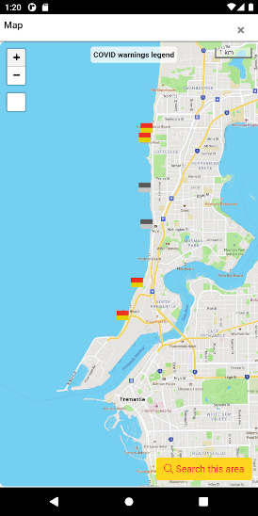Beach safe is an Australian app that informs beach goers of the potential hazards in an area of coastline. As well as this, it contains the lifeguarding service hours for each beach and the nearest ones that are patrolled. Whatsmore the app contains lots of information on the current sea conditions, plus their forecasted values as well, this includes: windspeed, water temperature, swell, tide, and beach attendance numbers. This app again is mainly designed to allow people to inform themselves on the conditions of the area and how safe it is to surf or swim there.

**Parts that I can apply to my solution:**

Overall, this is a great app providing people with huge amounts of information in an area; but for most people this information won’t be applicable to weather it’s safe to use the sea. As they don’t know how the tide affects the safety of an area, or how a particular wind direction could all of a sudden create massive waves crashing onto the beach. Therefore, my solution will be mainly an abstraction of this app, using similar to this a particular area of coastline of a country, and processing lots of this data, but instead outputting (before delving deeper into the user interface more) less clutter and information. Delving deeper into this app, we can find features such as graphs for the tide, swell, temperature, and other weather conditions; this does to an extent help as it provides those with more knowledge of an area, and knowledge of what actually makes a beach dangerous, with even more information to make better choices. However, for those with little knowledge of the dangers of a beach it’s confusing and discouraging, so they may not even try to check how safe a beach is next time due to the perceived complexity of it. This is where my program can be adapted to process this data but also provide a simpler solution to the user.

In addition to this other features that I can apply to my solution would be, the patrol times of each area, so the times the lifeguards are on duty and therefore informing them to only swim during these times. Plus I could also have a designated section of the GUI (graphical user interface), showing basic beach safety, such as what particular flags mean, the hazard sign meanings and what to do in an emergency situation.

SwimSafe

**Overview:**

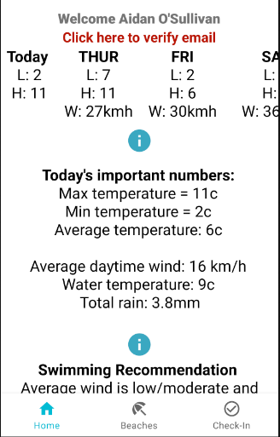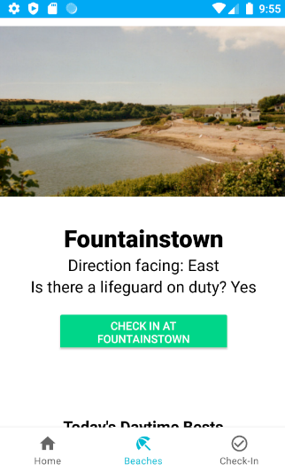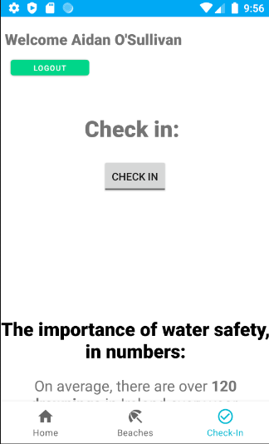SwimSafe is a very similar product to beach safe, with information about the various beaches in an area and their weather conditions, containing wind speed, highest temperature, lowest temperature, and wind direction, amongst others. As well as this it contains other features such as a check in function and basic open water swimming information.

**Parts that I can apply to my solution:**

This information is simply provided to the user with very little application of how it will affect their swim or visit to the beach; so apart from the obvious factors such as temperature or wind a user with little knowledge on this topic can’t apply the information being provided. Therefore, my app needs to solve this section of the problem, one approach is to only provide those with little knowledge on this area with information that is applicable, such as it’s too dangerous to swim as there is a strong tide or rip currents. This reduces confusion, making the user more likely to use the app to make an informed decision on whether to swim or not; not just ignore all the information as it's too confusing. Finally, a check in feature for each beach is useful, however as my solution isn’t dedicated to open water swimmers but to the general public who may not even go in the water this isn’t the most useful, whereas an image of the beach is. As through this image can be signified the key features, such as if it’s busy, remote or doesn’t contain certain features they require, e.g: wheelchair access.

Weather widgets

**Overview:**

Weather widgets are customisable banners or sections of information mainly on phone backgrounds and websites. They provide an easy to read of the overview of the weather in a certain location for the user, saving time and simplifying often confusing information. The banners can be placed anywhere on screen in any size or orientation required. The way they work is by accessing data from an API, which feeds them the most recent meteorological information in a format that they can easily modify, and processing it so that it can be displayed in the required way for the user to most easily understand it.  
As you can see there is various different variations of the banners and abilities to adjust the information displayed on them in order for it to suit a variety of applications.

**Parts that I can apply to my solution:**

Firstly, this use of an API in order to fetch various meteorological conditions is something I will definitely be using as it allows me to collect and utilise current weather conditions as well as future weather conditions in my calculations. Proving the user with a more accurate evaluation of the dangers of an area through the use of displayed, raw data and a simple summary (provided by the calculation) of the overall weather conditions. In addition to this the moveable and adjustable banners highlight a feature that I could implement into my application, which is having an easy to read colour coded banner at the top of the page, simplifying even further the process of providing the safety information of a beach to the user.

Features of the proposed solution:

Initial concept of my solution considering this research:

The solution I have come up with to this problem is an application that firstly brings up a map of a section of coastline from Brighton to Eastbourne and with each specific beach sectioned off from one -another. This allows the user to click on a specific beach to bring up an overview of the conditions there, a picture of the beach and a simple statement telling them whether or not it’s safe to swim there, coloured if possible to simplify it even more. This will be determined from calculations of pre -written values such as tidal patterns; but also live and forecasted values such as wind speed, water temperature, ambient temperature, and wind direction. Which will be called from a rest API such as the one used in: < > . Also within the overview of each beach is an option to access more information (an advanced section), for those who know how to use it; but this will not be presented at first to the user as it may seem confusing, and discourage them from using the app. Which is far from the aim of this solution.

Limitations of this solution:

Of course, the largest limitation of my solution is that it’s of a smaller area compared to the entire UK’s coastline, meaning that less people are able to use it. It would be possible to make, however due to the specific dangers of each beach and area it would take an extraordinary amount of time to manually enter in the dangers of each area, such as fish ports or quicksand. In addition to this I have a great knowledge of this area, often visiting its beaches and sometimes sailing along it; therefore, I understand the area and can more accurately create an application that takes into considerations this. Plus, one of my stakeholders has great knowledge of this, as they own a house along this coast and regularly swim there as well. So, through their feedback I can make my model more precise.

Another limitation is that the application requires an internet connection to function as it determines the safety of the area through data, some received through an API, therefore these calculations won’t be able to be performed; plus, for those looking for this data individually on the advanced section of each beach overview it won’t be displayed as it can’t be accessed. Although this could be combatted by storage of a forecast of this data such as predicted rainfall and wind speed, it won’t be as reliable as live data, especially if it’s for a long time in advance.

Finally, one consideration is that in practice it would be best to run this software on a phone as it’s portable and more convenient than a computer running on windows, or Linux. However, Python is only possible on android phones through an emulator, so even though I will mention how it’s possible to run on a mobile phone, most of this solution is based off a ‘desktop computer’ and its’ software.

Further interaction with Stakeholders:

Software and Hardware Requirements

Hardware:

Overall, the application doesn’t require many input or output devices, only a touch screen or mouse to select which beach the user is interested in, and a screen to output the information required and to allow the user to interact with the app. In addition to this a reasonably capable processor is required to perform pretty basic calculations on the conditions of an area from various inputs and output an answer whether it’s ok to swim or not. In addition to this an internet connection is required to access the live weather data from the API. Plus, to also receive predictions of the future conditions and inform people on the day of swimming (as forecasts get more and more unreliable the further forward in time they are asked to predict), for how long it’s ok to swim.

Software:

**Windows, Linux, or Mac operating system –** These operating systems support python, and the libraries I require.

**Python Interpreter –** As my program is written in python and run though it, a python interpreter is needed.

**Pygame and Requests < > libraries for Python –** These are the libraries that my program requires to run; pygame will be used to display a user interface, and requests will be used to access the data through the API……

**For android –** Like previously stated, it is quite difficult to use python on any mobile device, but it is theoretically possible in android through the use of an **emulator**, I will not be designing or altering the application just for mobile devices, it will be aimed to run on a computer with Windows, Linux or Mac operating system.